Living With Passion
By: Andre Walls

“He’s got such a creative mind and his creativity is immediate,” Leiviska said. Whether it is djing, playing tennis, or picking up surfing lessons, Redfoo feels that the importance of staying busy and learning new things is a key to happiness. “As long as you’re passionate about something go for it,” Leiviska later explained. At 38-years-old Redfoo intends to defy the odds and compete at a high level despite his age or loss of practice throughout the years.
Redfoo is the current sponsor of the Party Rock Open held at Stacy Darling Center. With his unique flair, he hopes to bring more attention and popularity to the game of tennis. From the bright pink banners to the zebra print pants, the tournament certainly does not lack originality.
In the minds of this mother-son relationship, anything is possible. Passion gives you motivation, positivity keeps you going, and learning is infinite. “Get out there and try everything,” Leiviska said. “Just be passionate and that’s the real win.”
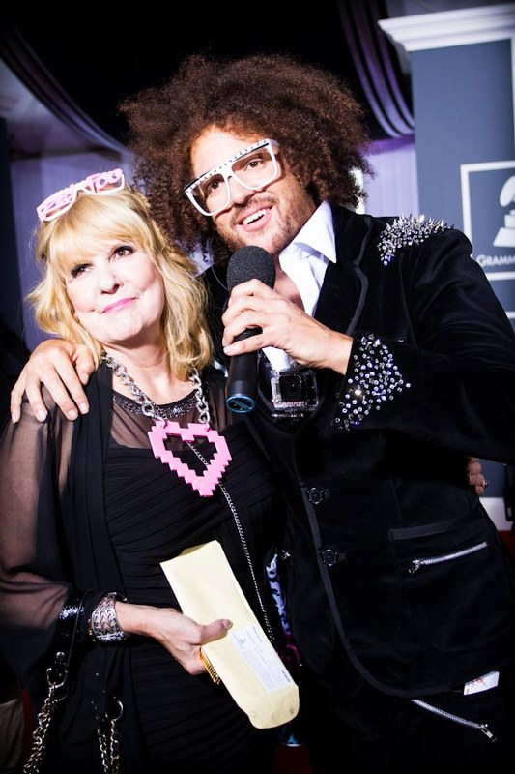

Nancy Leiviska and son Redfood

